We have completed the following topics:
- Basic idea of Machine Learning
- Data Gathering
- EDA (Exploratory Data Analysis)
Now, we can gather data and perform basic-level analysis.
Furthermore, we will discuss Feature Engineering.
What is Feature Engineering?
We do not give all the raw data directly to our model.
Instead, we perform some processing on the data and then feed it to the model.
This entire process is called Feature Engineering.
Feature engineering is an Art. Every programmer has different methods and approach to do Feature Engineering.
Feature engineering is that important people says if you give messy data to a Good algorithm and structured and well manner features (columns) to bad algo then bad one will perform far better than good one.
Below picture shows the parts of feature engineering. It is like one kind of Process.
Feature Extraction
Feature Selection
Feature Construction
Feature scaling

Outlier Detection
Handling categorical Feature
Missing value imputation Transformation
Feature Transformation
Feature Engineering

Feature Transformation:
transformation means you have a column and transform that column into another form so that it performs more well while training.

- Feature Transformation is the first step in feature engineering
- In feature engineering we have following things.
  - Missing value imputation.
  - Handing categorical feature
  - Outlier detection.
  - Feature scaling.
- Missing value: In this our column there are some missing values so we either fill it or remove it.
- It is less so we simply remove it. If there are many values and it is numerical 50 either me replace it with mean or median.
- if it is categorical then we replace it with most frequent category.
- This is the first step of feature trans formation and feature engineering Life cycle.

- Handling Categorical Values:
- our library to not accept categorical data it accept only numerical data so we have to transform categorical data into numerical data.

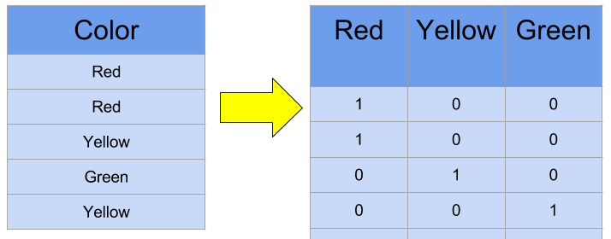

As we cam see is given example there are 3 colour. We transformed them into 0 and 1 so it is acceptable by our model. This technique called one-Hot-encoding.
- Outlier detection:
- we detect outlier and remove them before giving data to our model.

- Feature scaling:
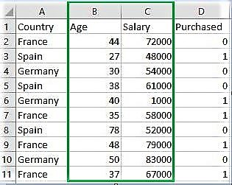

After all the+C+I transformation we are giving our tatu to the model. But the scale between one model is vary so what me do is we Convert them into a range most of time -1 to 1.

2. Feature construction
- Feature construction means we create completely new column from existing columns.

In the example You can see that we had 2 existing columns sib and Parch means Siblings and Parent child relationship so we merged both columns any created a single columns called family.

3. Feature Selection
-> when we give our data to the model me to not give all the columns we select important input columns and then we give it to our model.

4. Feature Extraction
-> Feature extraction means taking important information from raw data and converting it into simple numbers that a machine learning model can understand.

